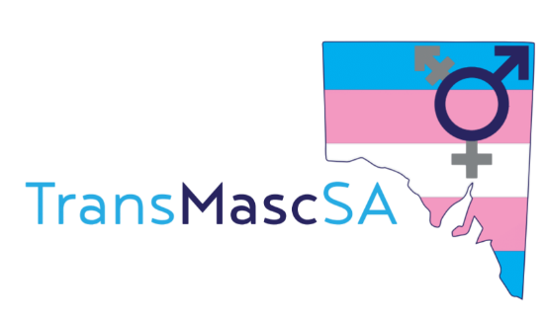
Getting Ready to Study?

- Letting your teacher know your name and pronouns

This template is designed to be used for students, University/Tafe/High School, to help them politely request a teacher use their correct name and pronouns when their legal documents and enrolment details may be different.
It is always a good idea to also research if your educational institution also has any policies for gender diverse students so you can quote them to the teacher and/or coordinator if needed.

Dear (insert name),

I am a student in your class, (insert subject) on (insert time and day). You will see on your student list that my name is written as (insert legal name) however this is not the name I use day to day.
I am (transgender/gender diverse – select which you prefer) and use the name (insert name). I identify as (insert gender identity) and use (insert pronouns) pronouns.
I respectfully ask if you could please update your class list prior to our first class and use my name and pronouns as stated above.
If you have any concerns or questions please do not hesitate to contact me by reply email or discreetly in class.

With thanks,
(your name)

