Using Narrative Practice Online: my experience working in China

Michael Wing Kai Cheng

Master of Narrative Therapy and Community Work

December 2017

The Department of Social Work, The University of Melbourne

The Dulwich Centre, Adelaide.

Part 1: General Introduction

**Why internet counselling?**

As early as 1995, people have turned to the internet as a way in which to receive mental health services (Powell, 1998). Research in using the telephone as a platform for distance counselling actually began much earlier in the 1960s (Rosenblum, 1969). From a therapist’s point of view, this poses an additional important challenge in comparison to the conventional therapy consultation that is done when both the client and therapist are physically in the same room (face-to-face) - building strong rapport with the client. If the therapist was not able to see the client’s bodily gestures and facial expressions, would the therapist potentially miss any cues that may have otherwise been picked up?

This was the question I had in mind, that prevented myself and many others from doing therapeutic work through telecommunication. Until recently, with the worldwide pandemic, many people in the field are now looking into the possibility of therapy while maintaining social distancing or even when a city is under a lockdown.

Despite the concerns about online counselling, there are numerous benefits that arise from the use of the internet as a therapy platform. Studies indicate that clients felt a sense of freedom and were able to be completely honest and open with their therapist when using an online platform “without embarrassment or fear of judgement from therapists” (Cook and Doyle, 2002). The online platform allowed the clients to bypass the stress they faced when participating in a face-to-face therapy consultation, and therefore put them more at-ease. Furthermore, Cook and Doyle (2002) reported that participants of the study considered that online therapy was a positive experience, and that the relationship between the client and the therapist - what they termed the “working alliance”, was “collaborative” and “bonding”. Taking these into consideration, then building client rapport may not be as a big an issue as previously thought.

My knowledge of Narrative Practice also helped me with more effective therapeutic work online. Narrative Practice allowed me to be more creative and flexible in the way I work, opening me to new possibilities of using the online platform. I hope that by sharing my experiences of online counselling, more people in the field will be encouraged to explore the possibility of helping countless others through embracing the new technologies.

**How it began**

My experiences with online counselling began in 2014, when a family living 300km away was referred to me. At the time, I felt uneasy with the idea of giving an online consultation. However, after realising the family was not able to access any other expert help (with the closest large city being over 100km from where she lived), I agreed to conduct an online consultation with the family. The family found the sessions very helpful.

Having gone through my first online consultation, the huge potential of working with online clients came to light. Online consultation allowed for flexibility in terms of location (people can meet even if they are in different countries, or if they are in quarantine), and time (travelling time is eliminated, and meetings can be arranged any time of the day). The number of people I could now reach with the internet was unlimited.

Online services also help people in areas where local professional services are limited. According to a previous report (Jiandanxinli, 2016),the ratio of the number of psychological service professionals to population in 2015 was only 9 per 100,000 in mainland China, as compared to the ratio of 100 per 100,000 in the USA. The situation of psychiatric services is even worse, with only 0.15 psychiatrists per 100,000 in mainland China compared to 3 in the USA. Online services allows professionals from areas with more developed services.

**China and the internet boom**

People in mainland China have fully embraced the internet and technology boom with open arms. Phone apps are not just for connecting friends and families, but also highly integrated into their daily lives. Most people nowadays shop, order food, or even pay for groceries and taxi fares via mobile apps. Moreover, this is not limited to the younger generations in big cities, but even children and seniors in small towns and villages heavily use internet and mobile apps.

This integration of mobile internet and people’s lives means it is very common for people to look for solutions to their psychological health and relationships issues or even seek professional services through the internet. As a result, China is host to some of the largest online platforms for online counselling and psychological health services in the world. For example, jiandanxinli.com (简单心理) is a well established platform for online counselling, with over 100,000 active users and 700+ consultants. They help users to find the appropriate counsellors and psychologists, help them make appointments for online or face-to-face sessions, and arrange payment or even provide physical spaces or online platforms for therapy. They even have their own screening system for professionals wanting to be listed on their system, hold online seminars and classes for counsellors, and even have their own 2-years training course for people who are interested in entering the field. According to the statistics shown on their website, approximately 30% of the clients use online consultation. Another example is xinli001.com (壹心理), currently the largest counselling platform in China and claims to have 12 million users with 6000+ consultants and a backing of 12 million USD in funding. There are now over 20 organisations like them in mainland China operating in similar or smaller scales. These organisations show how the future scene of psychological health services might look like in the coming years around the world.

**The advantages and disadvantages of online counselling**

Various research in the last 3 decades point out numerous advantages to remote and online counselling. On top of the many pragmatic reasons related to location, accessibility and financial benefits, there are also advantages related to positive experiences of the client. Online counselling can provide anonymity, equality, ubiquity, a wider range of therapists to choose from, and ease of recording (Peng, 2007). Certainly, the reduction of costs and time are highly beneficial to those who live in small towns and rural areas. Access of multimedia, and the ease of supervision are some of the other advantages (Yang, 1998). Additionally, the familiarity of the surroundings that the client is well-adapted to can also be favourable for the client (Mallen & Vogel, 2005), rather than being in the therapist’s office. The “power differential is diminished” as clients experience greater equality in the sessions during online consultations (Mallen, Vogel, Rochlen & Day, 2005).

However, there are also some issues that should be taken into consideration when conducting online counselling. There are some concerns that the therapeutic bond between the client and therapist could be altered due to the lack of “contextual and nonverbal cues that may be present in a face-to-face environment” (Mallen & Vogel, 2005). There may also be times when the therapist may need to “literally spell out for the client how he or she is reacting” (Mallen, Jenkins, Vogel & Day, 2011).

From my own experience, emotional cues are not always clear. In fact, effective use of communication during (and between) the sessions can aid in further enriching communication between the therapist and client.

**Area/scope of interest**

The effectiveness of my therapeutic work through the internet has been of great interest to me. I conducted a project a few years ago to answer some of these questions.

In this project, I hope to identify strategies that would help to more effectively communicate with online clients. This project is divided into 3 parts:

1. After a number of online therapeutic sessions, clients who agreed to participate are interviewed about their experience.
2. The use of therapeutic documents was explored. Clients received documents I formed using the contents of the previous 2 to 3 sessions. They were also encouraged to send me documents to help them reflect, and to keep track of significant experiences in between sessions, or respond to my documents.
3. The possibility of forming therapeutic groups was explored.

Ten of my online Chinese clients seeking individual therapy were selected as participants. Of these, six participants had previously used face-to-face counselling services. All of them were very excited about the opportunity to participate in this co-research.

In this project, I hoped to identify strategies that would help answer these questions:

Would I be able to build the rapport through online communication? Would I miss emotional cues through video-conferencing that may be picked up otherwise in face-to-face consultations? Would I be able to conduct these consultations in a manner that was equally as effective as face-to-face consultations? Would I be able to adapt the techniques that I have acquired from Narrative Therapy training into my online consultations, and how effective are they?

Most mobile communication apps nowadays can be used for real time video conferencing, and are also very useful means for text and graphic based communication. The internet also has many other powerful tools for text and graphic based communication that are not real-time. Many therapists have hesitation about contacting clients outside the therapy session. But for Narrative practitioners, the idea of therapeutic documents sent via email is common. I believe mobile apps can be a powerful tool to enhance the therapeutic process.

Part 2: My online consultation experiences

**Challenges encountered during online counselling sessions**

When seeing a client online, we are limited to the technology that is readily available. This includes the clarity of the video-conferencing, the available band-width on both sides, the problems with time-lag or even the connection dropping. I am also no longer in control of the environment. Clients could be in their own home, in their office meeting room, even in the streets, in a cafe - wherever they choose to be, or where it is available or convenient for them.

In my experience, the main challenges I have faced include the following:

* *Are they crying?*In face-to-face consultations, it is easy for the therapist to observe a person crying, whether it be tears silently coming out of their eyes, or loud bawling/wailing. However, when relying on a phone app to communicate, it is sometimes difficult to pick up a client crying very quietly, or who has tears coming out of their eyes but in which they do not make any other obvious movements (such as dabbing their eyes with a tissue), or change in tone of voice. Sometime clients would even just leave for a moment, and you would not know if they went to get a glass of water or were crying.
* *Other missing emotions*Small details of facial gestures or movement in someone’s eyes are not clear during video-conferencing, and body language may not be visible in the camera. Emotional changes would be more obvious when meeting face-to-face. I have also encountered clients becoming angry or sad because of what had been talked about, but purposefully looking away (as if they are distracted by something in the vicinity), or purposefully zooming out the image on the webcam so that I cannot see the finer details of the facial image. When a client intentionally does these things , there are often underlying reasons for this, and it may be important for the therapist to be able to pick up these cues. But once again, if the therapist does not realise that these events are happening, this can negatively influence that consultation, in addition to subsequent ones.
* *How do I know if they still trust me?*How would missing such important information affect the overall consultation quality? How much does it affect the rapport between the therapist and client? The therapist missing this would lose a vital piece of information which could have been otherwise beneficial to their consultation. I would also be worried about assumptions made by the client - does the therapist not realise I am upset? Why did the therapist not care that I am crying? Should I continue to see this therapist? Is there any point to continue seeing him if I don’t feel they can see what I am going through? Having said this, there could be opposite effect with the missing emotional cues - it could make the client feel more secure that these emotional cues are not picked up by the therapist, and could in fact make some people feel better because they would not need to ‘expose’ themselves unless they choose to.
* *Are they being distracted?*It is very hard to tell if the client is looking at another direction because they are thinking, or being distracted or disinterested. In face-to-face consultations, this is readily picked up due to body language and the way in which they respond. During online consultations, therapists may have little information about what is happening in the clients’ environment. For example, often I would not know if someone knocks on their door, or if a child or a grandmother stepped into the room to talk to the client. So whenever they are not looking at the camera, I would wonder, is it because they are distracted by something happening in their surroundings? Or are they in deep thoughts?
* *A new cultural shock for every new client*Cultural differences are not restricted to online consultations, but is certainly something that I have come across during my online consultations with clients from different locations. As I now get clients from different parts of China, the challenge in cultural differences is more significant. From the differences of their accents, to how they see basic values like marriage, relationship, family, study, work, etc. It is more important to be alert about the possible cultural differences and not make any assumptions. But how much do these differences affect the therapy?
* *Culture of Shame*Quite often in China, people are not willing to discuss, or find it very challenging to discuss their emotions - even to their own immediate families, especially negative emotions as it can depict ‘weakness’. In my own experiences, “naming the problem” is a difficult task for many Chinese people. Many of my clients continue to criticise themselves as being ‘inadequate’, or ‘bad’ and deserve to have these problems happening to them.

**Narrative is the answer**

When many non-verbal elements are missing, the verbal exchange in therapy becomes even more important. I have found that many Narrative skills are especially helpful for online consultations. Although a lot of facial gestures are hard to pick up, the tone and the words used by the clients can reveal a lot and be utilised with the relevant techniques.

Therapy is not just about “seeing” clients’ emotions, but letting their voices be heard, help them develop richer life stories, and provide a safe space for them to do so. In my experience from the past few years of using Narrative practice in my online work, I can see how the effectiveness of my therapeutic work has improved.

The authoritarian culture in China means that people are very reliant on the opinions of the professionals, or even demand us to give the directions and answers. As a Narrative therapist, it is important to keep in mind we are actually the “outsider”, despite being considered the “professional”. We need to respect the insider knowledge of the people we are working with, and help them to also realise this themselves. These insider knowledges “are local, particular and at times unique as they often arise from imagination and inspiration”, and we must help our clients to see the values of these, rather than to rely on our so-called expert knowledge from the “usual technologies of scientific knowledge-making” (Hancock and Epston 2013).

**Externalisation with visual means**

Externalisation is a very important step in Narrative therapy. As Michael White pointed out that culturally “it is not at all unusual to find persons engaged in internalising conversations about that which is problematic.” (White 1994)

With the clients being in their own home, many people are seeing me in front of their own desks. I had realised that externalisation is very effective when they are using pens and paper, or even colour pencils, to help them visualise the problems they are facing.

Many people see their problems related to some “inner voices” they have. The following is an example of how a girl described the problem as an inner voice, she called “Opinions” inside her. She came to see me for her difficulty to speak up her own ideas at work, especially when her work environment is quite stressful. After some exploration, we came to realise that her difficulty began at home since she was a child. I tried to explore the effects of her difficulty but she seemed to be unable to name the problem itself. She was mostly self criticising. Therefore I asked her to get some pens and papers, and draw out how her relationship with “Opinions” was like.

With herself being in her own room, in front of her own desk, together with my presence in her computer screen, I found she was able to feel calm and focused. She spent some time trying to draw the a diagram of how the “opinion” interacted with her. She was able to use her phone to take a picture of what she drew, and send it to me while we were still connected through our computers. After some discussion, she added how she reacted to “Opinions”. I was able to rescue her words and she put them into her diagram.

The following diagrams are replications of what she drew.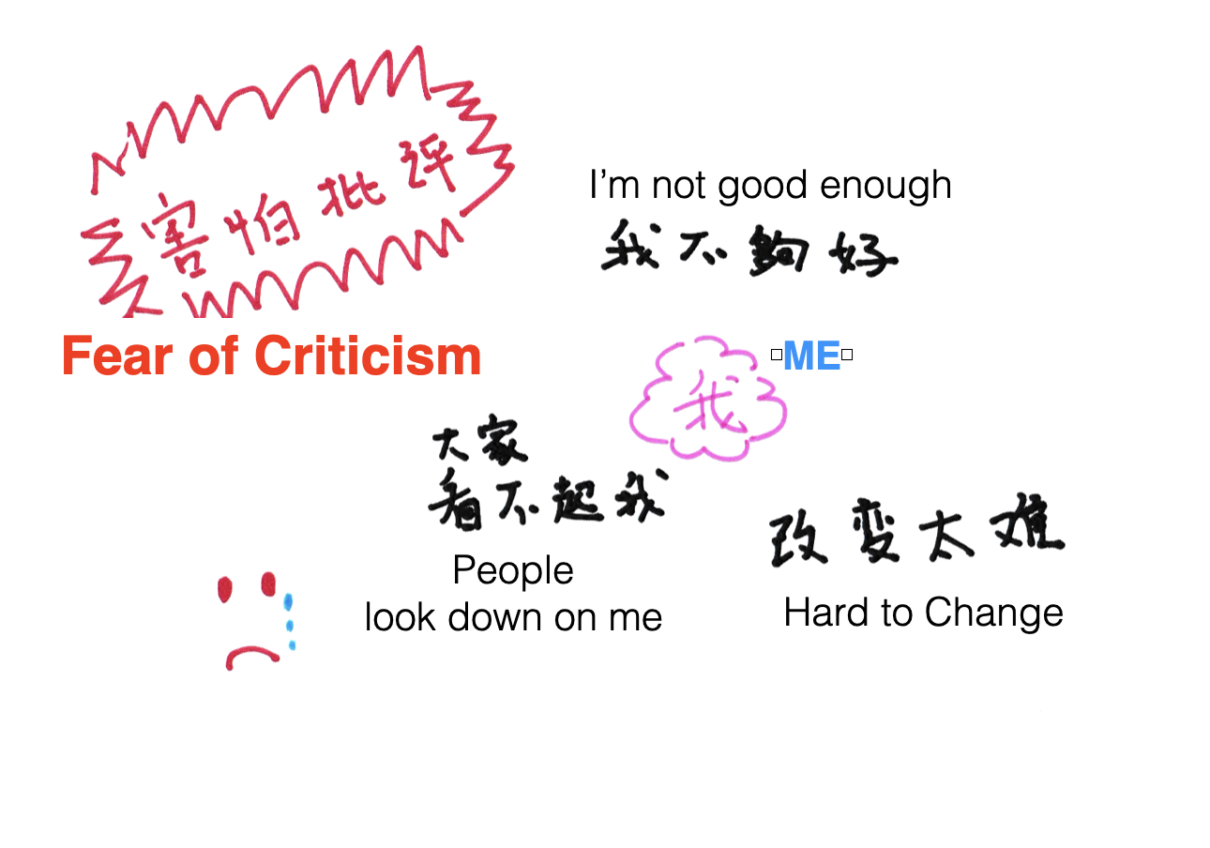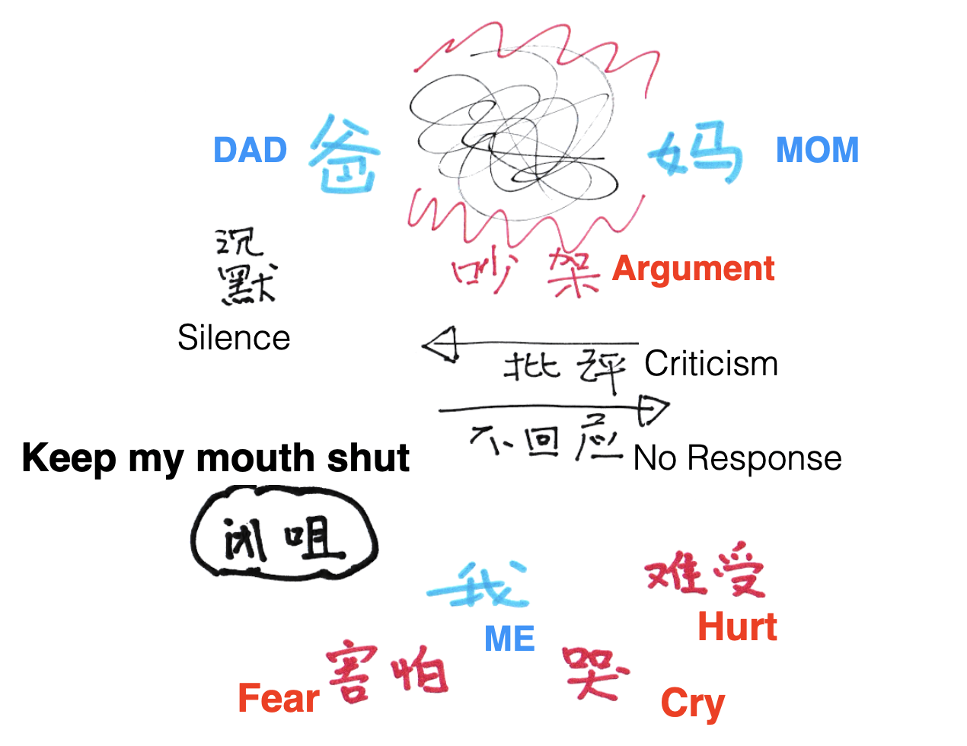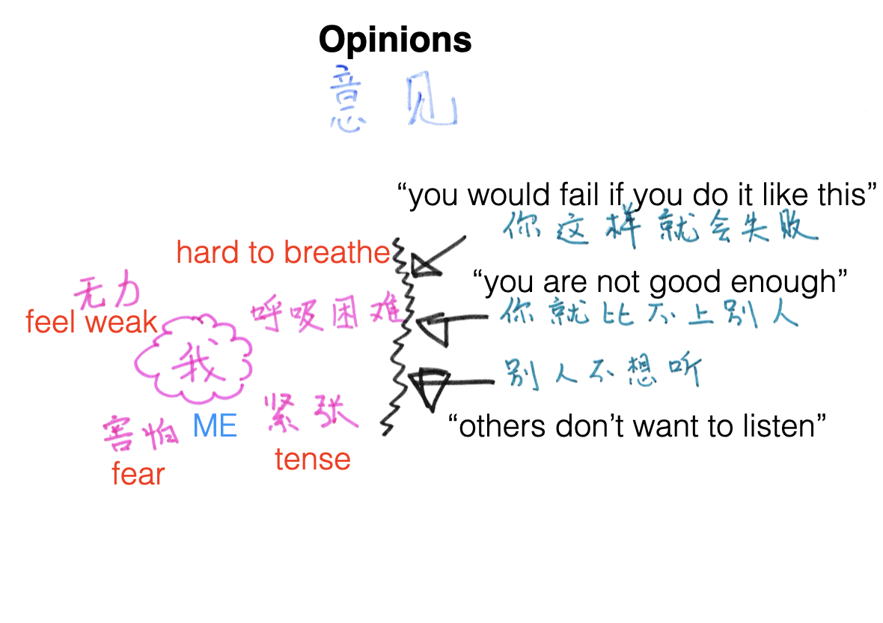

**Figure 3: How the voices began**

She wanted to explore how the voices began. She realised that whenever her mother got upset, her father would not respond to her anger, and whenever she tried to intervene, she would be told to “shut up”. She would quietly walk away, feeling hurt and in fear.

**Figure 2: Naming the voices**

After exploring what the voices was telling her, and the effects they had on her, she changed the name of the voices from “Opinions” to “I’m not good enough”. After some further explorations, she decided to name the problem as “fear of criticism”.

**Figure 1: What the voices are saying**

Whenever she tried to speak, the voices were telling her how she is inadequate and would never grow up or change, or it would be telling her that speaking up is being disrespectful.

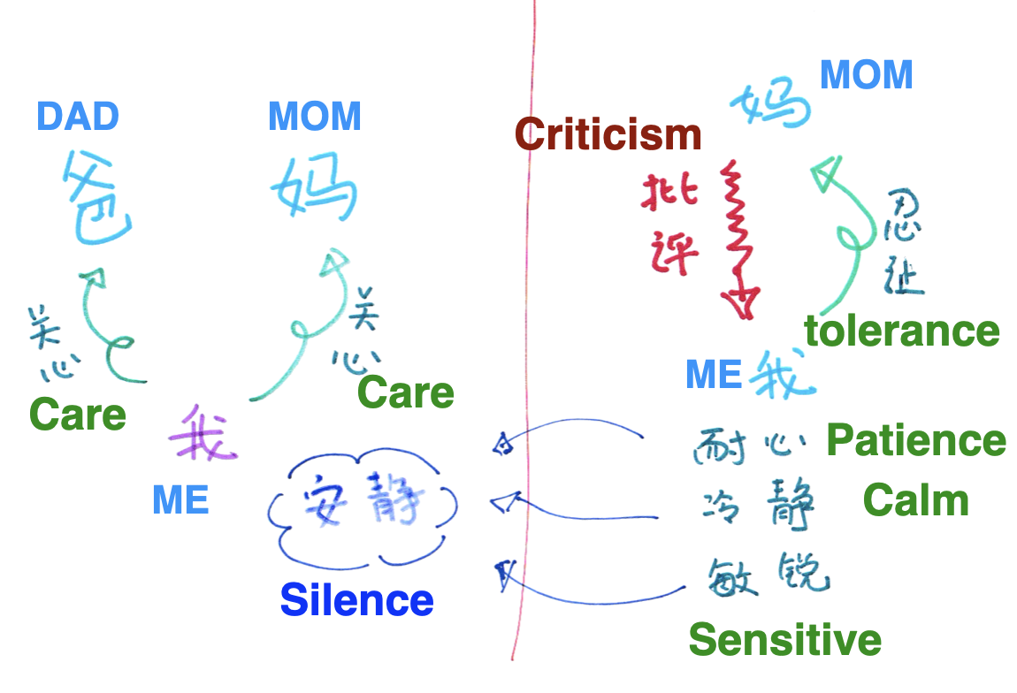At this point, she decided to name her way of response as “Silence”, and inside “Silence” are her caring qualities of “Patience”, “Calm” and “Sensitive”.

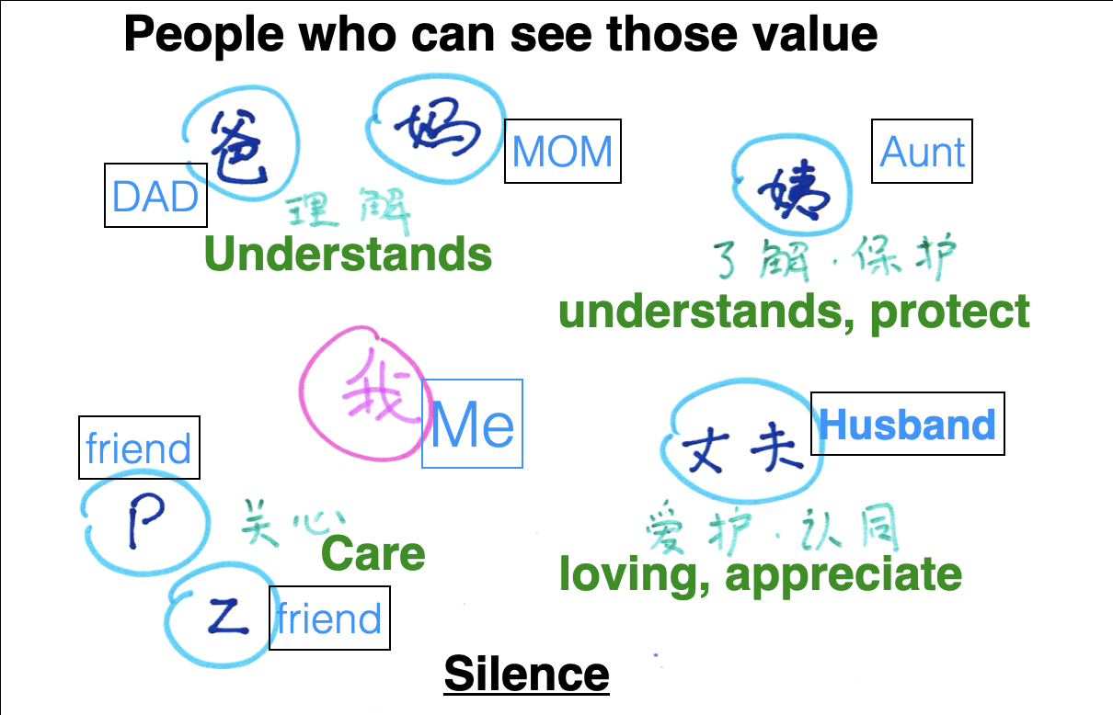

At this point, she no longer see the inner voice “Opinion” as a problem, and she also see her “Fear of Criticism” as “Silence” with lots of values and strengths that some of the people closer to her can see. We then were able to explore the other ways she can face the stressful environment at work where she could find ways to see speaking up as a way to help her colleagues and be responsible.

**Figure 4: Absent but implicit**

Seeing how she would stay with her parents even when she was scared, I was able to help her realise the care she had for her parents. She also saw her fathers response as an attempt to be tolerating to the mother.

**Figure 5: Re-membering**

Then I asked her if there were people who saw these caring qualities about her. She realised her husband understood, and also some of her closest friends told her that she was a very caring person. She also had an aunt who tried to protect her from her parents criticism.

These “inner voices”, before exploration, were creating huge guilt, pressure and sadness. Our urge to “help” by encouraging them may add to guilt and make them feel even more hopeless. Naming these voices, and using Externalisation and Re-authoring, helps the clients to “create distance from problems, and creates options” (Pederson).

To hold “conversations about trauma without re-traumatising” (Yuen) is an important concept I had been referring to, of how to create a safe space for these clients. Most of them do not mind talking about these self-criticising voices they have inside and the effects they have in their lives, even though it could be painful at times. However, it’s the way they talk about their experiences that reinforces their self-concept of being insignificant and defeated. Helping them to explore, without the vicious cycle of self-defeat, or even seeing their own values and dreams through the existence of these voices, were found to be helpful. Asking about “actions they took and how they respond”, rather than circling around the effects and feelings of the negative feelings, was helpful. People have their own way of adapting to challenges, and their actions are important references of their knowledge about their lives and the values they hold.

As explained by Michael White, the engagement with externalising conversations “made it possible for people to separate their sense of identity from problem-saturated or deficit-centred accounts of who they are” (White, 2000). In my experience, these “inner voices” are the highlights of their problem-saturated part of their identities. Using Narrative techniques helps to provide the safe-space for them to examine their problems.

**Use of documents**

Mobile apps make it very convenient to communicate with people via text, pictures or voice messages. Many therapists are worried how opening up this channel of communication would lead to the client messaging the therapist even in between consultations with the expectation of a reply, or even seeing it as a breach of their personal space. Therefore, many are very reluctant to use these technologies to communicate with clients.

In my experience, although there are small number of clients who may have tendencies to do so, people would understand that quick responses would not be guaranteed. The purpose of messaging is to help with the therapeutic process rather than answering immediate questions. Therefore, I would explain to them we should focus on the content of the previous session and observations between sessions that are related to that.

One young man told me that his previous counsellor refused to add him in “whatsapp” (the most popular instant messaging app in Hong Kong, the city where I live), and would only contact him through phone calls. He found it very difficult to relate to the person, as “no one use the phone these days”. I asked a few teenagers and young adults I was working with in mainland China about this issue, and some agreed that not being able to contact someone one instant messaging app feels “untrusting”, “distant” or “uncomfortable” about the relationship, especially for the young people. The younger generation often grew up with the instant messaging apps as their major mean of communication. This is something we need to consider.

These platforms are also enable us to “create a context in which stories can be told and developed and meaning-making can be shared” (Freedman 2014). In fact, many of my clients seem to find it helpful when they realise they can use the instant messaging apps as a platform for them to write reflective documents. Some of my clients developed the habit of writing their “reflections” on their phone, or even their social media accounts (many young people have “hidden” accounts or account which they do not disclose their true identities, where they keep logs of their daily lives or personal notes), and they would copy and paste that to me. They find it therapeutic knowing that their voices are being heard, even though I may not respond to each document.

Part 3: Clients feedback

An important part of this project was to investigate the experiences of online therapeutic sessions. After seeking their consent,, 10 of my clients agreed to participate. Six of them had previously experienced face-to-face therapy sessions, and would be able to compare the experiences of the two. The other four (all seeing me in the traditional “face-to-face” setting) agreed to try seeing me for 4 to 6 sessions to experience the use of online therapy.

Each of the participating clients would be interviewed for approximately one hour. After discussion with some of them, I decided not to use one single set of questions, but rather to interview them related to the following themes:

1) The logistics (time and location)

2) The difference in experience of online and offline (ie: face-to-face)

3) Their experience with the use of documents

**The Logistics**

All the clients participating in this co-research gave feedback that somewhat matched with the literature about the advantages of using online therapy. Their responses agreed with the idea of ubiquity (Peng 2009) and familiarity of environment (Mallen & Vogel 2005). Furthermore, these have deeper implications than just the convenience and comfort at which an online session can be arranged. The following are some of the responses that I think highlights the significance of the aspects of logistics.

* “I can truly feel normal/being myself when I’m in my room”   
  *(3 of my clients had this as the first thing they thought of. All the other 7 agreed with this point when I asked them. 4 of them thinks being in a therapy room actually feels more like a “social” environment and is harder to be themselves)*
* “It has been impossible for me to see my previous therapist because of the travelling time and odd working hours. I really appreciate how I can be seeing you in my own office, especially when the problem I’m facing mainly happens at work”  
  *(long working hours is a major challenge that pushes the client to turn to online therapy. Also, family engagement or the* *long travelling times are important factors that make it difficult for them to see a therapist in a conventional face-to-face way. One of my client travels frequently due to work arrangements, and found that online therapy was very helpful for him to deal with his stress at work, especially when he can see me during his work trips.)*

* “The experience of talking to someone outside the family in my room, really put things in perspective for my relationship with my family”
* “I believe I can express myself more when I’m in my own home, rather than a counselling room. I would hold back my thoughts and feelings when I’m outside, just like I do at work”   
  *(in fact, many people still relate entering a therapy room as related to being weak or having a mental illness. Being able to talk about their problems without going into a therapy setting is very comforting for many people.)*
* “I think I’m feeling quite lazy when I’m in my room. Too laid back”   
  *(this young person had a slight negative comment about seeing me in the comforts of his own room. However, when suggesting he could choose another place to see me, this young man said he preferred to see me in his own room)*
* “When I’m in my room I can use my laptop to type in your questions and my thoughts, and can be at my own pace to answer your questions, which I found it impossible to do during face-to-face consultations in the therapy room”  
  *(this client had the habit of typing into his laptop what he considered as important quotations from our conversations. Initially I felt quite uneasy. However, I came to realise that this is a way for him to gain some autonomy during the process. He later proved that this action has long term therapeutic effects for him. He also shared some of our thoughts during our sessions in a chat group with his friends when he found appropriate - please refer to the first answer under “use of documents”.   
  There are other clients who also feel more free to record certain elements of our conversations, including taking notes, drawing pictures, or forming mind maps during the process, as comparing to being in a therapy room)*
* “I felt intimidated talking in a therapy room no matter how comfortable the room appears. In the future, if I ever have a face-to-face session, I would rather do it in a cafe”  
  *(in fact, I have a number of clients of face-to-face therapy sessions who would not see me in a therapy room. In China, many cafes and tea houses have private rooms, and some clients prefer to conduct therapy in there)*
* “Being in Holland, it is nearly impossible to find a counsellor who can speak my language”  
  *(at the moment I have clients seeing me online from different parts of mainland China, Taiwan, USA, Australia and a few different countries in Europe)*

Online therapy certainly breaks the limitation of the physical locations. But the effect is beyond just convenience. For me, the possibility to work from home or from other locations during my trips, means I can be more flexible to meet the needs of my clients. On the other hand, it also becomes a challenge to make a balance with my work and personal time and space.

As mentioned in Part 2, having little control with the environment can create some extra challenges. It did take me some time to get used to it, to deal with the distraction of the client by a child or a family member, or a client who picked a noisy cafe to have the consultation session. All these require flexibility to accommodate for the choice or limitations of the client.

For the clients, some of them told me after experiencing the possibility of getting therapy from a location of their own choice, they would prefer not to go back to a therapy room or a clinic again. Some think that they are still open to the options of both online and face-to-face, or after seeing how the two forms of therapy have different effects and are in fact complementary, and have since started seeing me online and office alternately.

A couple of clients mentioned the experiences of having bad internet connections, and how that was very frustrating when they were had to repeat themselves or couldn’t hear my responses at times. I also had the experience of having to reconnect multiple times, or even reschedule because of the poor internet quality. However, reviewing those experiences with them, none of my clients saw these as significant problems.

**The difference in experience between online and offline**

Those who had previously experienced face-to-face sessions had the following feedback.

* “I cannot see your body language. I get to observe how a person is really like when meeting face-to-face. I feel that I do not really know you until a number of sessions, and I always wonder if your therapy would be even more effective if we could meet in person.”
* “I feel more comfortable with that distance between us. It gives me a sense of self-control and autonomy. But at the same time, I am always curious how it would be like meeting you in real life.”
* “I think people are more ‘flat’ when in front of a phone camera. When face-to-face, people would become more interesting.”
* “I feel like I can tell you more because we don’t really know each other, but at the same time, we do know each other. I think the distance does make me feel safe.”  
  *(An after-thought to this comment, I wonder if that feeling of safe space is related to him being in his own home, be more distant from me, or because of the experience with Narrative therapy)*
* “I feel like I can hear myself more, because I have less concerns about how you feel. But then, there are times I want to ‘see’ how you feel.”
* “Thank you for letting me switch off my camera. I feel very uneasy being ‘seen’ by a stranger, especially a male. But I really want to know about how a male would respond to my questions. I think all these would not have happened if we were not able to meet online.”  
  *(I met some female clients requested to not showing their faces, at least for the first couple of sessions.)*

Regarding the client-therapist alliance, and the experience of talking to a therapist through a phone or computer app, the feedbacks are mixed. But with the effectiveness of therapy, after weighing the pros and cons, most of them still believe online therapy is to them as effective, if not better. With how much more comfortable they feel in a familiar environment, and without the difficulties associated with transportations and travel time, some say this is the only way they can have regular sessions.

As a therapist, trying to build rapport with a client through a computer screen or even a tiny phone screen did take some time to get used to. At the moment, nearly all my clients who seek online therapy are people under 40, and most of them are used to communicating with friends and family through mobile apps, so they have little difficulties getting used to the technology.

**Use of Documents**

All clients had very positive feedback regarding the exchange of documents in between sessions.

* “I have been recording some of our ideas and thoughts on my laptop during our sessions. Sometimes I would share these ideas with my friends when I see appropriate. Their feedbacks are usually very positive. Being able to help others, as well as being seen by others as wise and knowledgeable is very empowering. I can really see how I have grown in wisdom and experiences.” *(This is the person who likes to take notes on this laptop)*
* “It was since my high school years that I’ve stopped writing a diary. These experiences have reminded me of how helpful it is to write down my thoughts and feelings in terms of helping me with my personal growth”
* “In the past with other therapists, I realise once I get back home I became my old self and all the problems came back as if nothing had happened during the therapy session. Being able to write down my thoughts and share them to you, I realised I am reminded of all the possibilities we have found through the therapy sessions. This was really helpful.”
* “I have been tracking my ups and downs each day. To me it’s a testimonial of how I am so much more than a ‘patient with depression’. I get to appreciate how many good times I experience each week. And I feel grateful I may send some of my thoughts to you before meeting you in our weekly sessions, even more so when I get your reply.”  
  *(My replies are sometimes just “thanks for your sharing”)*
* “I felt so desperate every time my husband refused to join me in therapy. However, I actually see changes in him just by forwarding to him the messages we have been exchanging”  
  *(although the online sessions have made it difficult to see couples or families together, I realised this sharing of documents is a way to help the family. This client later was able to convince her husband to participate in the writing of documents to the children, which helped them to improve the family relationship despite him still refusing to participate in therapy sessions)*
* “Whenever I feel hopeless I would read the notes I have written down during our sessions, and the messages that we have been exchanging. It helps me to realise I already have the answers to nearly all my questions in life.”
* “It’s really through seeing my own writing that I see how my mind really works. I had been approaching life with too much logic and too little emotions. I used to only write when I’m required for study or work.”
* “After sending you my weekly reflections through voice messages, I have slowly developed a habit of recording my thoughts talking into my phone. Now I would listen to my audio recordings for the week every Sunday night. At first I found it very hard to listen to my own voice, but after your encouragement, I realise this is the most therapeutic thing I have done for myself. It has helped me to reflect on how to become a better mother. I also feel more confident to share my thoughts to others.”
* “I am so going to publish a book about my healing!”

All my clients have very positive feedback about the use of messaging apps or email to exchange documents with me. It does take up some of my personal time to read their messages. But many of them show significant changes even between the 2 or 3 messages they send me in the 1 or 2 weeks between sessions. This also help me to understand them more about how they really feel during the week.

Occasionally I get clients who would send me lots of messages and demand replies. But as I would have already explained the purpose of these exchanges of documents, these clients also came to realise that these were some of the issues they needed to face regarding their difficulties in their social lives or their anxious feelings.

**After-thoughts**

After the discussion of these 3 themes, some of my clients and I began a discussion about how the internet has affected our concept of “identity”. Most of my clients have more than one app to connect with friends and work. Some of them even have different accounts for different purposes. The way in which each person choose to express themselves through each of these accounts revealed aspects of their concepts about identity which we did not discuss during any of our therapy sessions.

The theme of identity also came up with the further discussion about “location”. Sometimes the personality they are showing through online therapy could be different from how they interact with friends, or people in the workplaces. To talk to a “stranger” or “outsider” in their own home helped made some of them realise how each of these personalities may be different but were inter-related.

Although a few of them felt there may be a psychological distance between us regarding our client-therapist relationship that had developed through the online platform, during the subsequent discussions, most of them realised what mattered was not about whether we could see each other in real life or not. We had so many different faces online or offline, and before therapy, they did not think about these different identities. Deep inside, some of them had uneasy feelings about these fragmented identities. Two of my clients actually told me they used to feel that having so many accounts sometimes made them feel like they had split personalities or thought they were being a fake at times. But with this discussion of identity, they realised that these were part of their “real selves”. Most of them found it helpful that I (with Narrative therapy) helped them to see that these differences were not a problem, but in fact could be “alternative stories” of who they can choose to be.

**Online Groups**

To explore the possibility of “online outsider-witness practices”, I invited two of my clients to be the outside witnesses for a young man who had been struggling with his career choices. The two were selected because they were of similar ages and education background, but also living in small towns in different parts of southern China. We formed an online chat group and did a session of outsider witness. All 3 of them found the session very helpful, and the others requested they want another session with the other two in the group.

They all agreed that the experience of being an outsider witness, to feedback on the what they heard about the stories of others, rather than commenting with personal opinions or giving others their solutions, helped them to become active listeners at work and in their personal lives. And their cultural background are also closer than I am to them, they could see things in each other’s stories which I would have missed.

I reflected on these experiences of witnessing their personal growth and realise that because they are not only more understanding of each others experiences, but They have been able to tell stories in a more authentic way in each others presence than in my presence the outsider to their culture. As Aunty Barb said, narrative approach is to “make it possible for people to be able to tell their stories in ways that are right for them” (Wingard 2001). This kind of peer group seems to be a good platform for these types of therapeutic story telling.

After a month, one of them consulted me about starting an online peer group so they may chat constantly. I then found out they actually added each other as friends on the mobile apps before. I agreed, and I requested to be in the char group as an observer. They would exchange their thoughts about life and interesting reading they found on the internet which they found meaningful to share.

Two months ago, I encouraged them to start sharing their life experience by answering questions on [zhihu.com](http://zhihu.com) (the biggest “Q&A” discussion forum in mainland China, where people post questions and others can answer. With over 220 Million registered user and over 30 million questions asked, you can find questions and answers of all sort of topics. It has became an important source of knowledge for many people interested in psychology and health) responding to questions which they have some experiences in. All of them found it amazing that each of them could write very thoughtful and caring answers, and found this experience very encouraging.

The result of this group has encouraged me to consider forming more online groups, especially for people who live in small towns or have difficulties finding friends whom they can trust to share their life stories.

Till today I still wonder if it was appropriate not setting stricter rules to maintain anonymity between them. But witnessing the group developed in the past 3 years, they have become very good friends, and constantly giving each other great support in their journeys of personal growth.

I had attempted another few times of outsider witnesses after that, using online conferencing apps. Sometimes people still add each other to their mobile apps, even when I suggested the session should be one off. Witnessing how this group developed in the past few years, makes me wonder what would be a “good” setting for outsider witness practice online.

Part 4: Concluding remarks

This project was conducted few years ago to get a better understanding of the experiences of online therapeutic sessions, and to find ways to improve the effectiveness of therapy.

Through the discussions with my clients, I realised doing therapy sessions online not only is convenient and break through the limitations of physical locations. The new form of communication opens up new possibilities if we can be creative

With the worldwide pandemic in 2020, online therapy is a way to allow us to continue with our work. In fact, not just therapy sessions, but supervision, lectures and group work can be done online. On one hand, the experience of being physically together can hardly be replaced by online communication. But with some creativity we can surely discover how to make online work more effective.

The upcoming generation will be growing up in a very different world. Most of the current therapeutic concepts and techniques were formed at the time when we still relied on “meeting in person” as the main way of “getting to know a person”. How relevant will many current concepts about relationships in therapy be for the next generation is something we may need to question.

My experience in the past few years using Narrative concepts and techniques online gives me a lot of confidence that Narrative therapy can be a very useful backbone for therapy in the future generations.

The new technology is still rapidly changing the way we communicate, the way we live, and how we form our identities. I believe it is time for us as professionals to embrace the new technology and work together to see how therapy may evolve with the rest of the world.

**References**

Coleman, R. (2013) *Recovery and Hearing voices*. 5 short videos by Ron Coleman. Video, Dulwich Centre

Cook, J. E., & Doyle, C. (2002). *Working alliance in online therapy as compared to face-to-face therapy: Preliminary results*. CyberPsychology & Behavior, 5(2), 95–105.

Freedman, J. (2014). *Witnessing and Positioning: Structuring narrative therapy with families and couples.* International Journal of Narrative Therapy & Community Work, (1), 11‒17. doi: 10.1002/anzf.1043

Hancock, F. &; Epston, D. (2013) *A narrative enquiry approach to strategic planning in community organisations: A ritual of legacy in transition,* International Journal of Narrative Therapy & Community Work,1, 46-57.

Jiandanxinli (2016). *Psychological health awareness & Psychological consultation Surverys 2016 Report* (心理健康认知度及心理谘询学业2016调查报告). jiandanxinli.com & Peking university Counselling and Therapy Centre. (published in Chinese. Available at [www.jiandanxinli.com/report2016](http://www.jiandanxinli.com/report2016) )

Mallen, M. & Vogel, D. (2005) *Online Counseling: A Need for Discovery.* Counseling Psychologist, v33 n6 p910-921

Mallen, M. J., Vogel, D. L., Rochlen, A. B., & Day, S. X. (2005). *Online counseling: Reviewing the literature from a counseling psychology framework.* The Counseling Psychologist, 33, 819-871

Peng (2009). *Using Narrative Therapy in Online Counseling to Join the Master of the Story in Re-Authoring Her Landscape of Life.* 中華輔導與諮商學報: 26 (2009 / 09 / 01) P203-237 (Article in Chinese)

Pederson, L. (2014) *Utilising narrative ideas when meeting with people experiencing suicidal thoughts by Loretta.* Video, Dulwich Centre

Powell, T. (1998). *Online counseling: a profile and descriptive analysis [On-line].* Available: http:// netpsych.com/Powell.htm.

Rosenblum, L. (1969). *Telephone therapy.* Psychotherapy: Theory, Research & Practice, 6, 241-242.

White, M. (1994). *The narrative perspective in therapy (Bubenzer, D.L., West, J.D. & Boughner, S.R. interviewers)*.In Re-Authoring Lives: Interviews & essays (chapter 1), pp.11-40. Adelaide: Dulwich Centre Publications.

White, M (2000). *Children, children’s culture, and therapy.* Chapter 1 in Reflections on narrative practice. Adelaide: Dulwich Centre Publications.

Wingard, B. (2001). *Introductions and Stories of Life*. In B. Wingard & J. Lester, Telling our stories that make us stronger. Adelaide, Australia: Dulwich Centre Publications.

Yuen, A. (2007).*Discovering children’s responses to trauma: a response-based narrative practice,* International Journal of Narrative Therapy and Community Work, 4, 3-18.